Course Name:  Course Code: | Digital Logic Design Laboratory (DLDL)  316U06L202 | Semester: | II
Date of Performance: | 04/ 03 /2026 | Batch No: | A1
Student Name: | Arav Arun | Roll No: | 16010125013
Faculty Sign & Date: |  | Grade/Marks: | / 2
Experiment No: 7
Title: Study of Flip-Flops
Aim and Objective of the Experiment:
To implement S-R Flip-flop using NAND gates. To Implement J-K, D and T Flip-Flop using J-K Flip-Flop IC

COs to be achieved:
CO4: Implement sequential logic circuits and applications using MSI devices.
CO5: Understand basic principles required for advanced Digital Design

ICs Used: 4x 7400

- Logic Diagram: S-R Flip-Flop using NAND gates
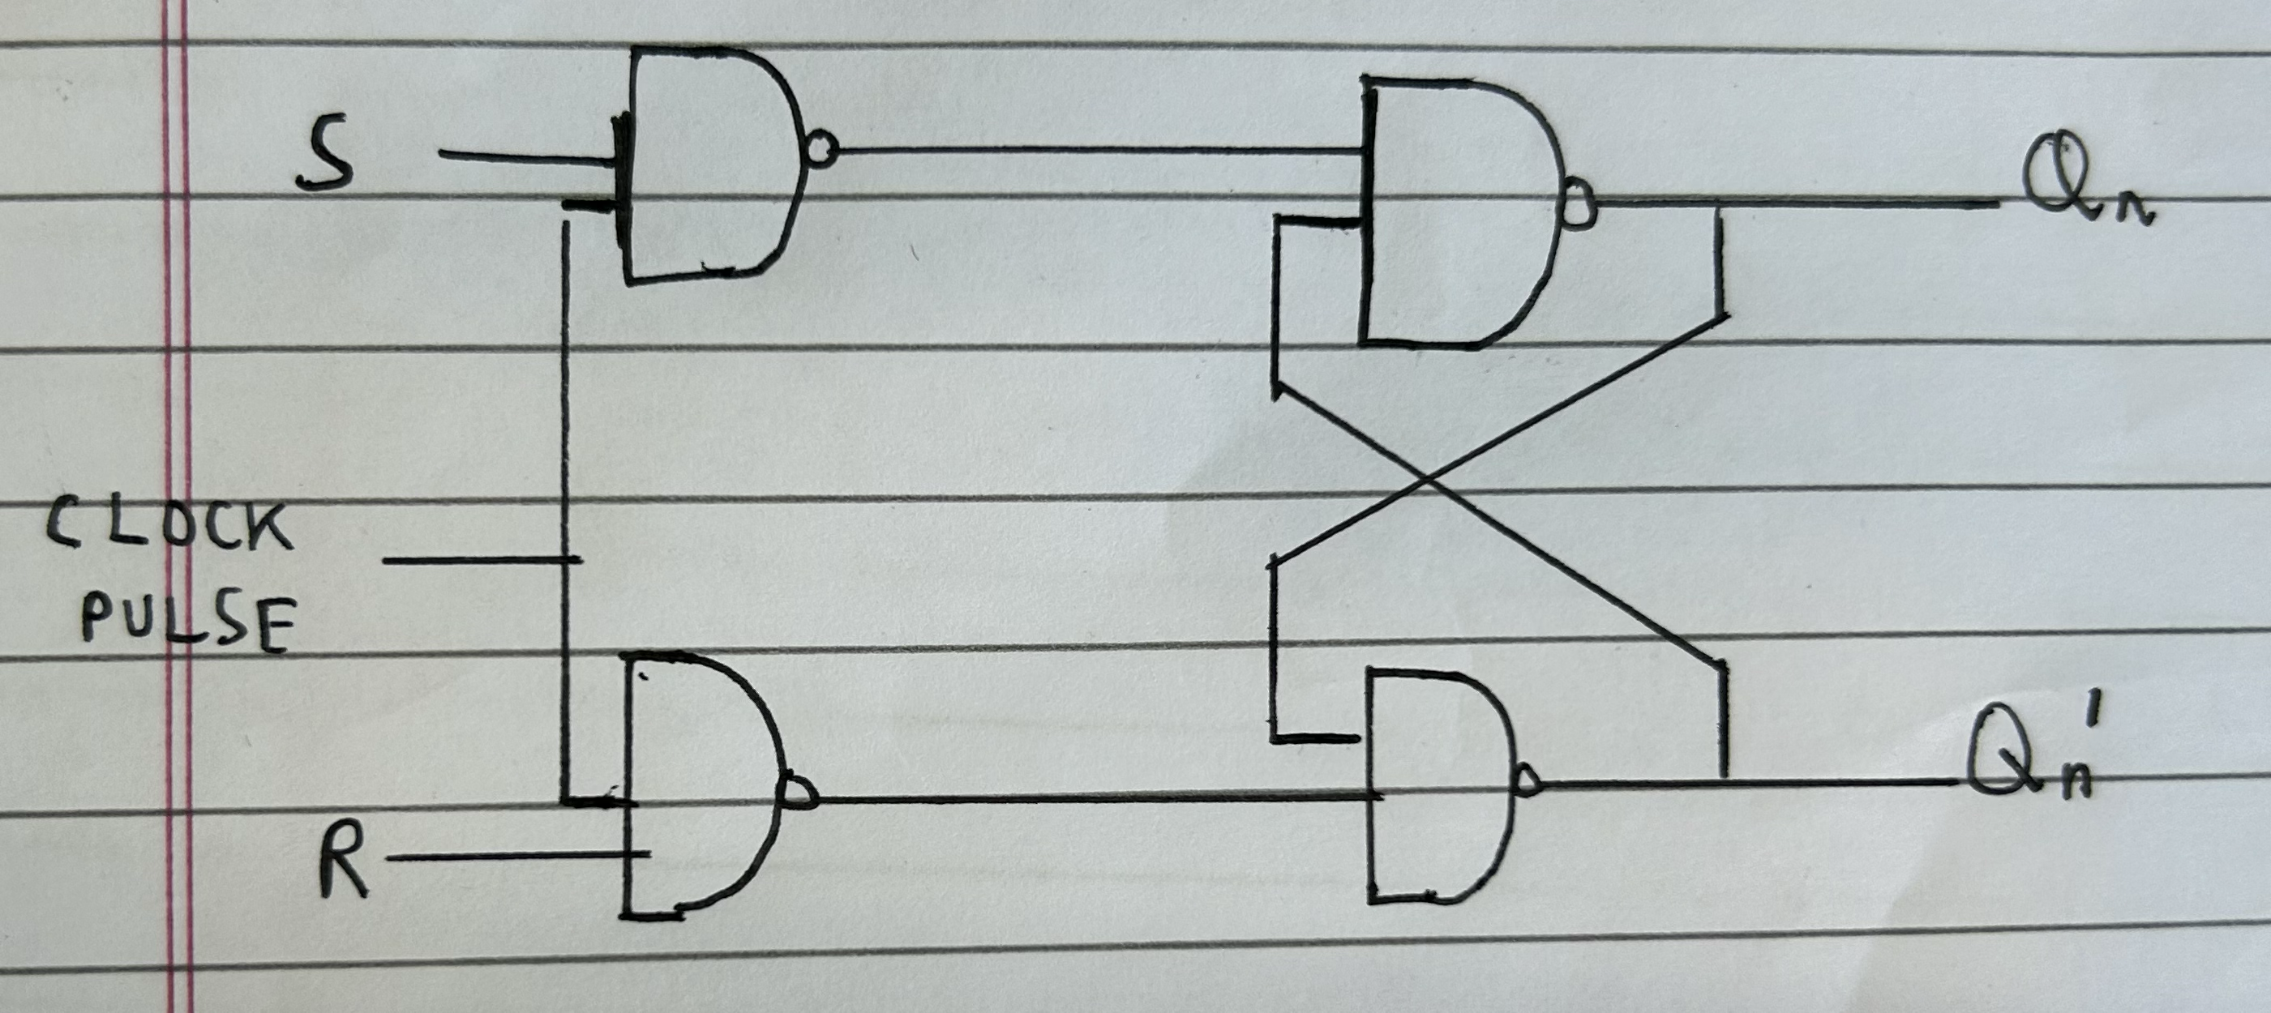

Truth Table: S-R Flipflop
Inputs |  | Output
S | R | Qn+1
0 | 0 | Qn (no change)
0 | 1 | 0
1 | 0 | 1
1 | 1 | indeterminate
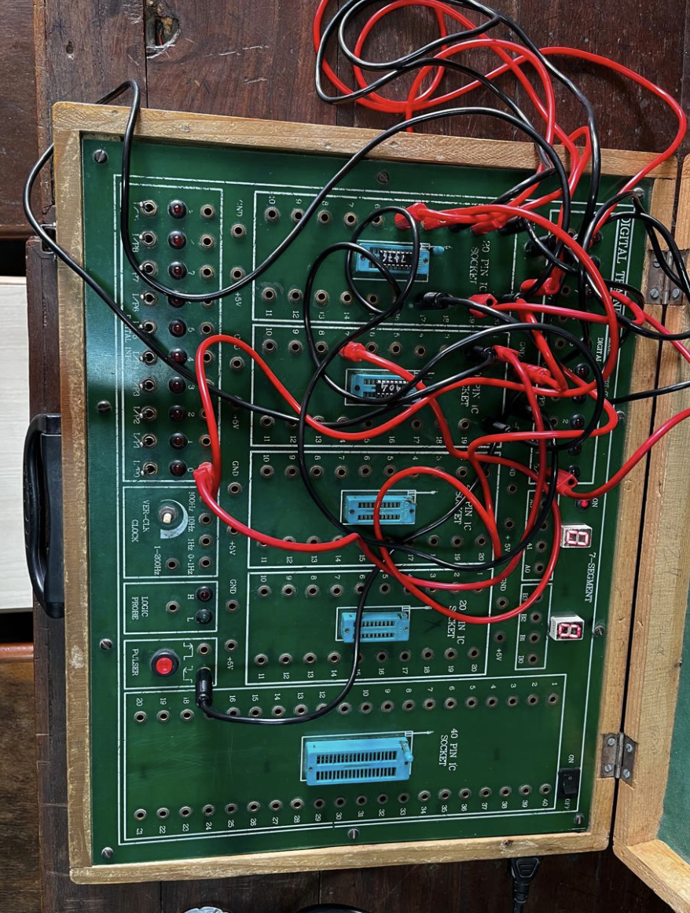

- Pin Diagram of J-K Flip Flop IC : 7473
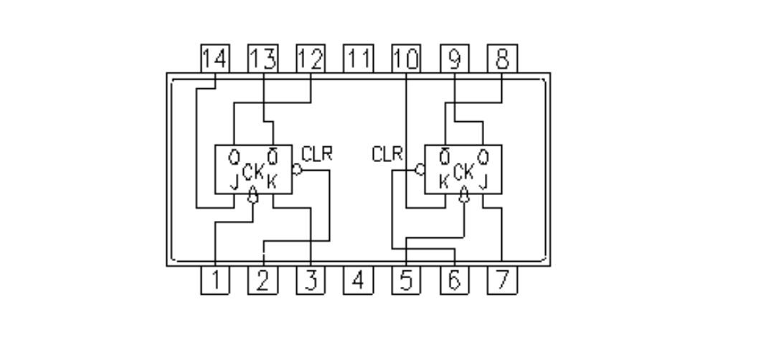

Truth Table: J-K Flip-flop
Inputs |  | Output
J | K | Qn+1
0 | 0 | Qn(no change)
0 | 1 | 0
1 | 0 | 1
1 | 1 | Qn bar (Toggle)
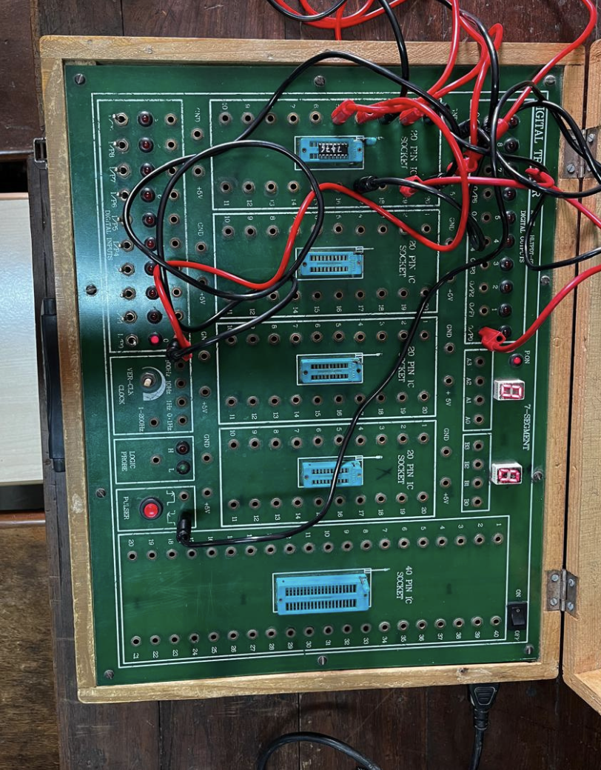
- D-FF using J-K Flip

Logic Diagram: Truth Table
Input | Output
D | Qn+1
0 | 0
1 | 1
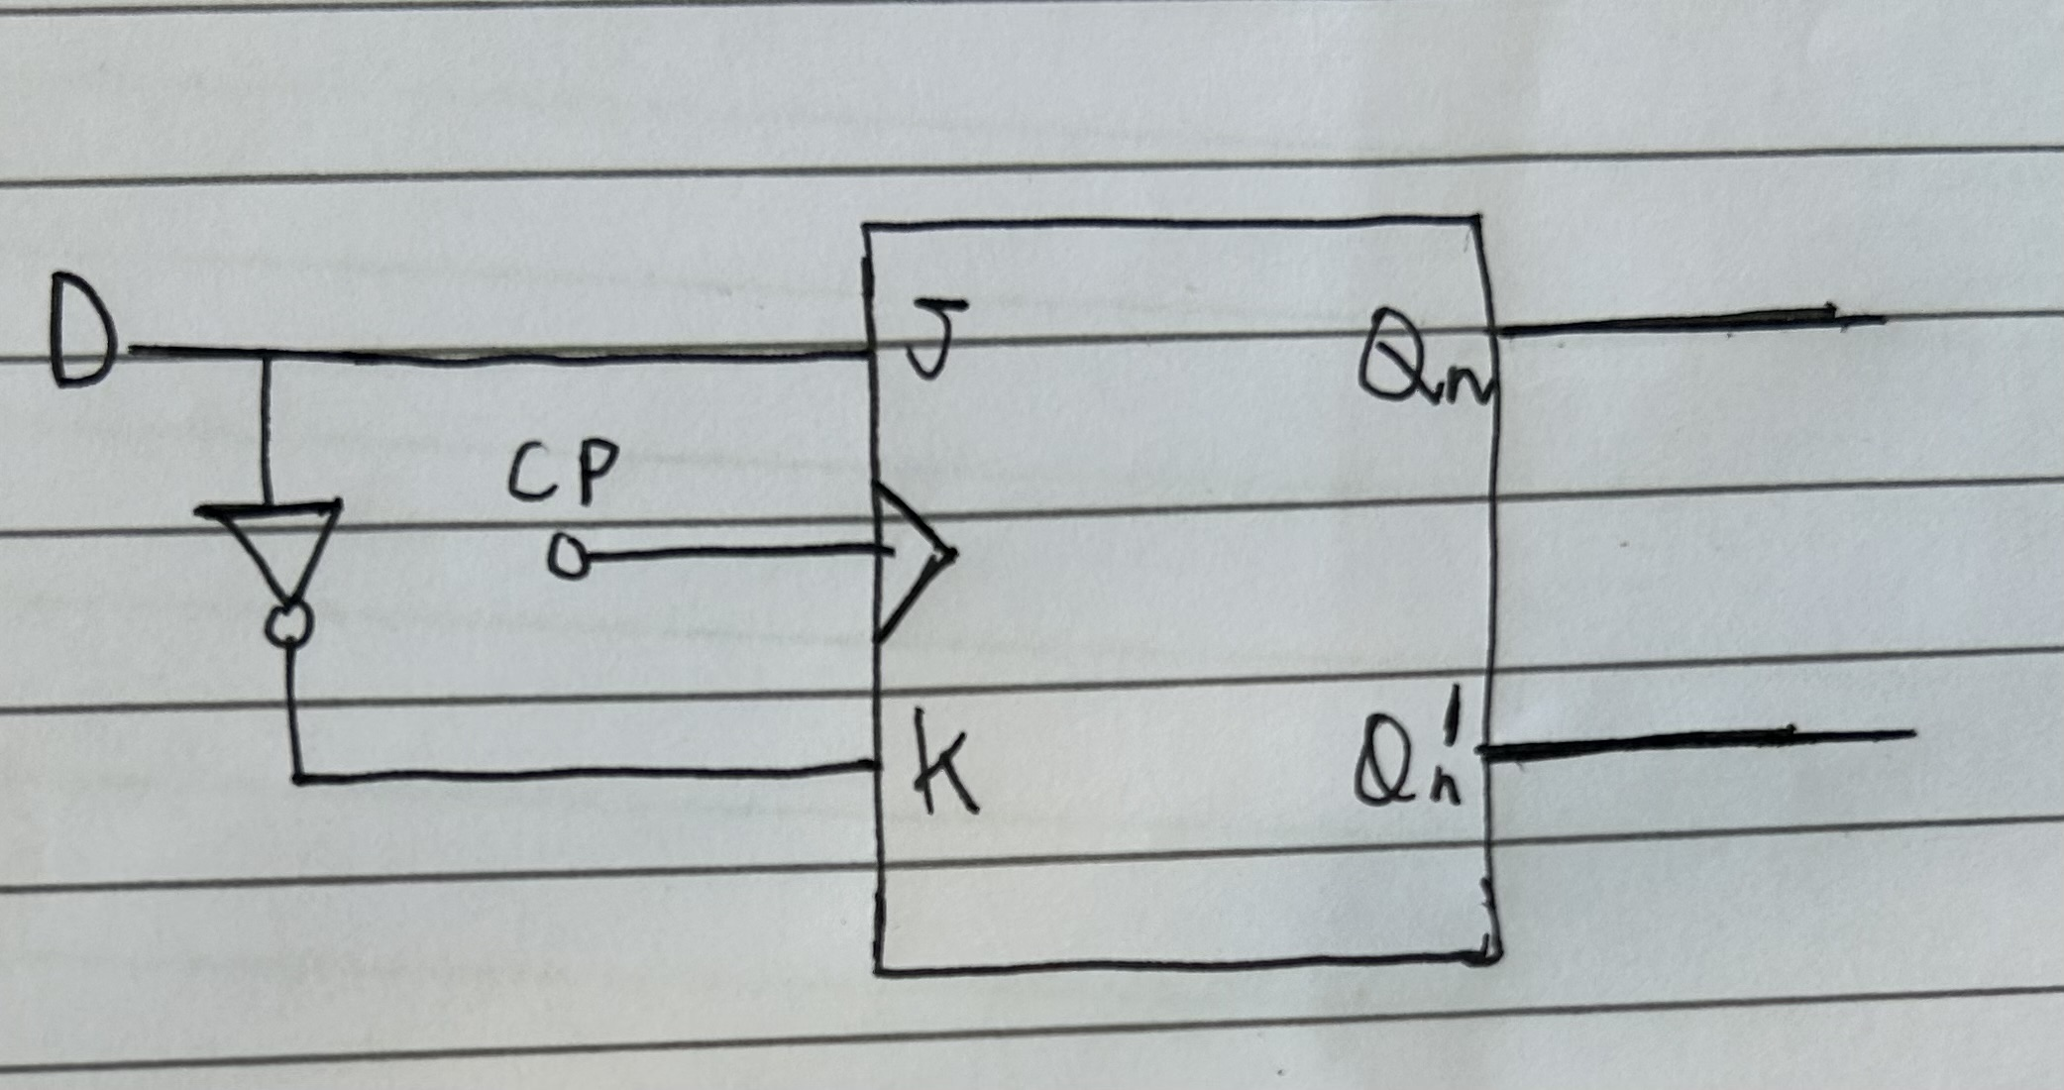

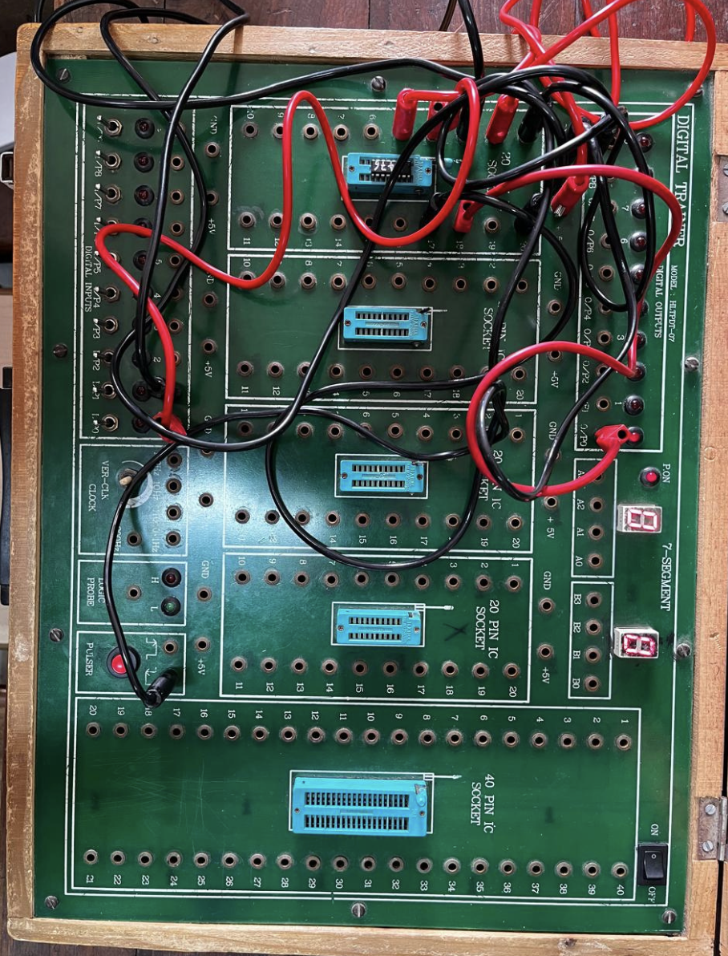

- T-FF using J-K Flip

Logic Diagram: Truth Table
Input | Output
T | Qn+1
0 | Qn(no change)
1 | Qn bar (Toggle)
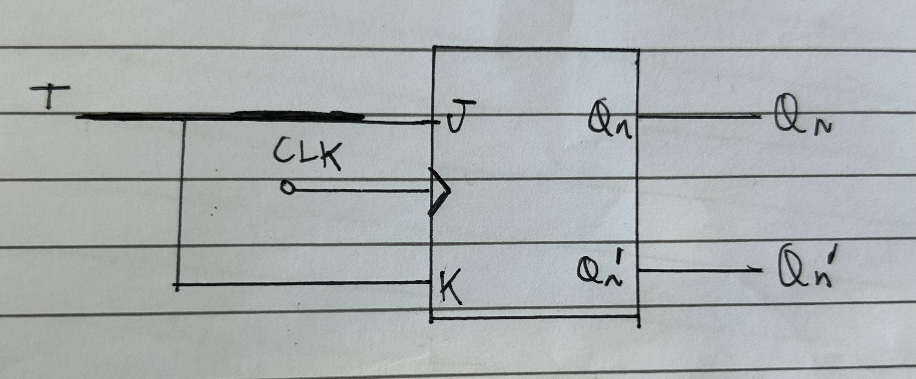

Qn | T | Qn+1
0 | 0 | 0
0 | 1 | 1
1 | 0 | 1
1 | 1 | 0

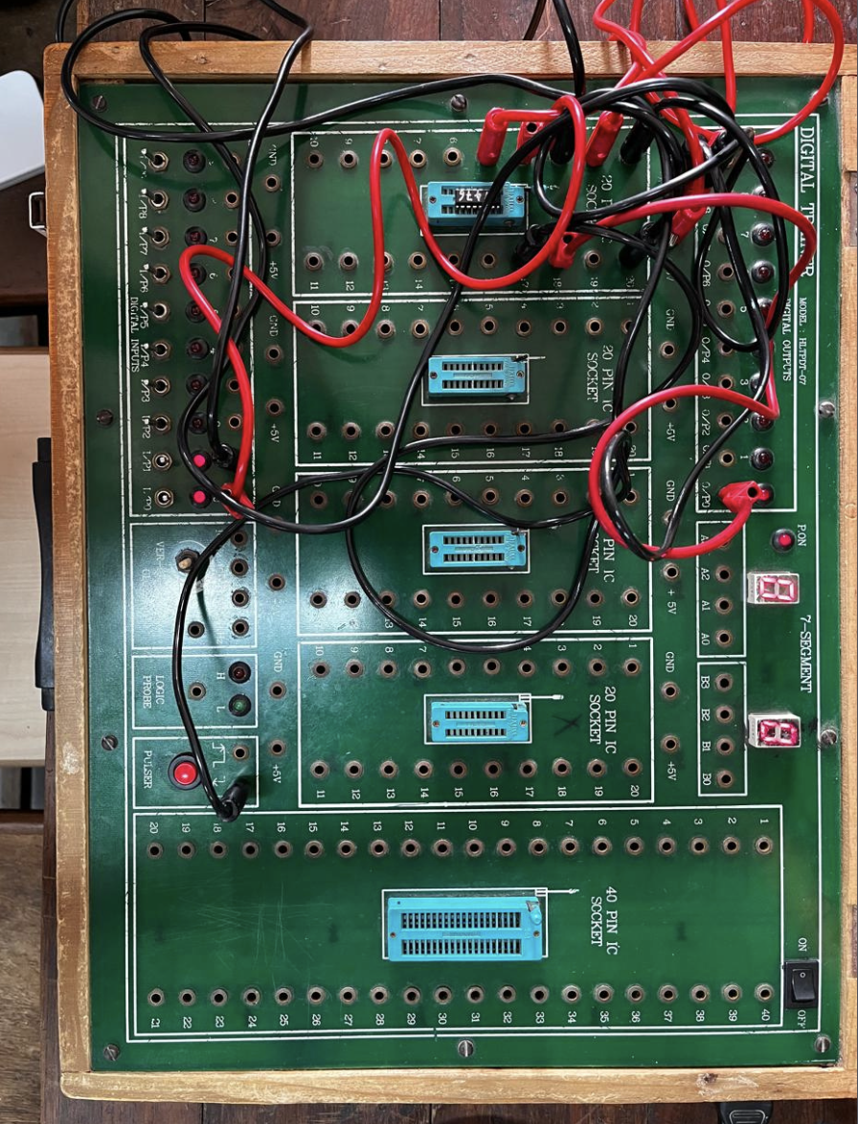

Conclusion:
In this experiment, the operation and truth tables of S-R, J-K, D, and T flip-flops were studied and verified. The S-R flip-flop performed as expected for both Set and Reset conditions, but produced an invalid state when both inputs (S = 1 and R = 1) were high. This limitation is overcome in the J-K flip-flop, which instead toggles its output when both inputs are high. The D flip-flop was observed to directly transfer the input to the output (Qₙ₊₁ = D), making it ideal for data storage applications. Similarly, the T flip-flop toggled its output when the input was high, which makes it useful in counter circuits. Overall, the experimental observations were consistent with the theoretical truth tables.

Signature of faculty in-charge with Date:

